Assignment - 4

Question-1:

Write code and connections in wokwi for ultrasonic sensor.Whenever distance is less than 100 cms send "Alert" to ibm cloud and display in device recent events.

Solution:

// Pins

const int TRIG_PIN = 7;

const int ECHO_PIN = 8;

// Anything over 400 cm (23200 us pulse) is "out of range" const unsigned int MAX_DIST = 23200;

void setup() {

// The Trigger pin will tell the sensor to range find pinMode(TRIG_PIN, OUTPUT);

digitalWrite(TRIG_PIN, LOW);

//Set Echo pin as input to measure the duration of //pulses coming back from the distance sensor

pinMode(ECHO_PIN, INPUT);

// We'll use the serial monitor to view the sensor output

Serial.begin(9600);

}

void loop() {

unsigned long tl;

unsigned long t2;

unsigned long pulse_width;

float cm;

float inches;

// Hold the trigger pin high for at least 10 us

digitalWrite(TRIG_PIN, HIGH);

delayMicroseconds( 10);

digitalWrite(TRIG_PIN, LOW);

// Wait for pulse on echo pin

while ( digitalRead(ECHO_PIN) == 0 );

// Measure how long the echo pin was held high (pulse width) // Note: the micros() counter will overflow after ~70 min tl = micros();

while ( digitalRead(ECHO_PIN) == 1);

t2 = micros();

pulse_width = t2 - tl;

// Calculate distance in centimeters and inches. The constants // are found in the datasheet, and calculated from the assumed speed //of sound in air at sea level (-340 m/s).

cm = pulse_width / 58.0;

inches = pulse_width / 148.0;

// Print out results

if ( pulse_width > MAX_DIST ) {

Serial.println("Out of range"); } else {

Serial.println(

Serial.print("The Measured Distance in cm :");

Serial.println(cm);

if(cm<100){

// while(true) {

Seri al.println(" Alert!!");

// }"

Serial pnnt(’’*******************************” } // Wait at least 1000ms before next measurement delay(lOOO);

}

Output:

1) If the distance is less than 100 cms, it alerts.

Docs A

hc-sr04.lno diagram ]son • Library Manager ,

1. // Pins
2. const int TRIG_PIN = 7;
3. const int ECH0_PIN ■ 8;

4

1. // Anything over 400 cm (23200 us pulse) is "out of range"
2. const unsigned int MAX_DIST - 23280;

7

1. void setup() {

9

18 // The Trigger pin will tell the sensor to range find

1. pinMode(TRIG_PIN, OUTPUT);
2. digltall.’ ：te(TRIG_PIN, LOW);

13

1. //Set Echo pin as input to measure the duration of
2. "pulses coning back from the distance sensor
3. pipHode(ECHO_PIN, INPUT);

17

1. // We'll use the serial nonltor to view the sensor output
2. Serial.begin(96ee);
3. }

21

1. void loop() {
2. I
3. unsigned long tl;
4. unsigned long t2;
5. unsigned long pulse_width;
6. float cm;
7. float inches;

29

1. // Hold the triaaer pin high for at least 10 us

Simulation

The Measured Distance in cm : 84.14 Alert!!

2) If the distance is more than 100 cms, it won't alert.

WOKWf B SAVE ▼ A SHARE ,

Docs A

hc-sr04.ino diagram json • Library Manager ▼

1. // Pins
2. const int TRIGPIN = 7;
3. const int ECHO_PIN = 8;

4

1. // Anything over 400 an (23200 us pulse) is "out of range'
2. const unsigned int HAX_DIST = 23200;

7

1. void setup() {

9

1. // The Trigger pin will tell the sensor to range find
2. pinHode(TRIG_PIN, OUTPUT);
3. digitalhrite(TRIG_PIN, LOH);

13

1. //Set Echo pin as input to measure the duration of
2. //pulses coning back from the distance sensor
3. pinMode(ECHO_PIN, INPUT);

17

1. // We'll use the serial nonitor to view the sensor output
2. Serial.begin(9600);

26 }

21

1. void loop() {

23

1. unsigned long tl;
2. unsigned long t2;
3. unsigned long pulse width;
4. float cm;
5. float inches;

29

1. // Hold the trigger pin high for at least 10 us

Simulation

*»***»X «»»****** ****»**««****4:4:

The Measured Distance in cm : 227.10 **»*******»*:««**««******»«»****4：4：**

Activate Windows

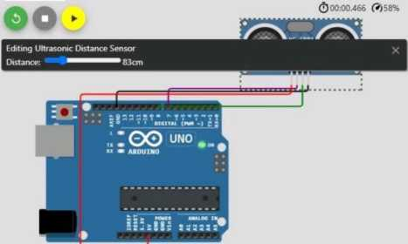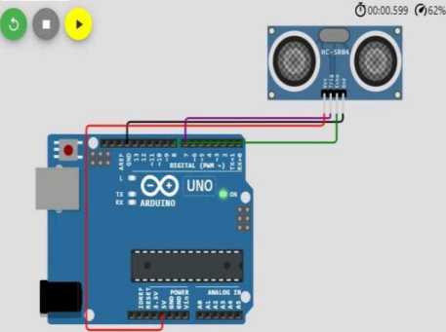

3) Simulation and code execution

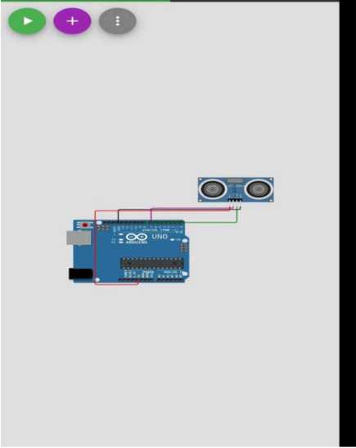

| 11：1O | | *ns* IWB s«i ..il C^aD |
| --- | --- | --- |
| O' A wokwi.com/proje | | ! CD ： |
| woKwr | ▼ | SHARE A |
| Simulation |  | Code |

| 11：10 < | *m* th .ill ® |
| --- | --- |
| O ft wokwi.com/proje | ® : |
| WOKWf • - =-« * | Doc *i* |

const int TRIG_PIN • 7; const int ECHO_PIN - t;

const unsigned int MAX.OIST • 232M; void MtupO <

"Th» Trigger pin will t«ll «he sensor to r«ng« find iU kmITHIS.PIN. OUTFUtJ:

dlt.-jl-, .:e(TRIG_PW, LOW);

"S«t Echo pin a< input to m>»ura th* duration of .Af- -(ECHO_PIN. IWUT>;

// We'll use the »rial aanlto* tn vim the lense' output Serial.I»fin(9eoo);

OO»

void loop() <

unsifned long "; unsigned long w: unsigntd long pulsejaldth: float ch:

*II* Hold the trigger pin high for at lo»t 10 ui .■r<TIH6J»IH. HIGH); t C (TIIG.PIII. lOM);

〃 Wait for pulio on ecM pin ohilo ( J.i-c .-(£CHt>_PI*) 0 );

"ho« long th» »cho pin mi h»ld high (pulw width) /' Note the Bicrosf) countir aill ovirriow »ftor -70 ain «•'ll» ( ” •: : . (ECHO.PIN) •• 1):

"Calculate dutame tn centlMtert <nd incnet. *nt «mtttntt* "are found In th» datasnvat, and calculator fro» the atcumd tpsoD c«i • puBo.eldth / 5«.0;

inch» » pulsojridth / 14B.0;

if ( pulse_Hidth > NAXJlIST ) { Serul.i' i-><‘Out of range’);

>else <

5erı»l.prıntCTh» Measured Dist«nc« in ci» "); Sar 141.print In(o>);

Serlol.pi mtîn(*Alert it t!”>：

*'1* Hatt «t lust 1000m befort next nuiurenant lel*»<10l»);



| ”14 -W | tt? »r til ..ii car> |
| --- | --- |
| O A wokwi.com/proje | CD ： |
| woKwr a ▼ > | SHARE A |
| Simulation | Code |

| 11:14 | *IS?*»R İli ..il CEZ> |
| --- | --- |
| ■O' A wokwi.com/proje' | + CD s |
| woKwr a ▼ * | SHARE A |
| Simulation | Code |

Editing Ultrasonic Distance Sensor Distance: 1 99cm

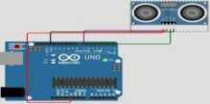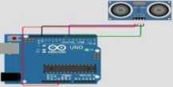

The Measured Distance in cm : 201.79

* *★* * * w* * ** * * ** ****** * ********* *******************************

The Measured Distance in cm 57.79 Alert it !!

*******************************